**Change the Volume Size of an Instance**

1 Creating the new volume which we want to add to an instance and clicking on **create volume**

2 Validating the Availability zone of the EC2 instance with which you want to add volume

3 Providing type, size, availability zone, and snapshot name on the **create volume** tab

4 Selecting newly created volume and clicking on the action to attach the volume to the instance

5 Selecting the instance of the same availability zone and attaching the volume in pop

6 Verifying the instance by adding one more device to the block device

7 Pushing the code to GitHub repositories

**Note:** By default, when we create a new instance, we need to attach the minimum volume to the instance depending on the OS or AMI. But we can also add or remove the volume.

**Step 1:** Creating the new volume which we want to add to an instance and clicking on **create volume**

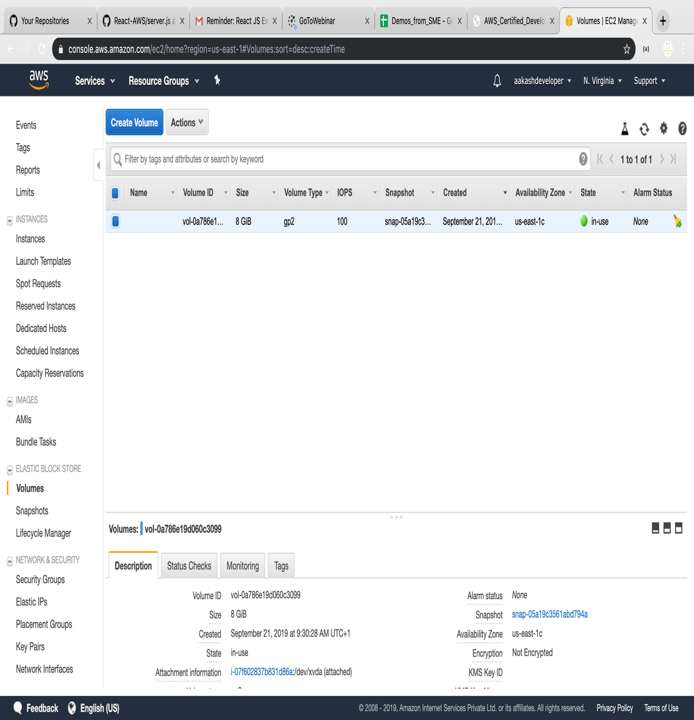

**Step 2:** Validating the Availability zone of the EC2 instance with which you want to add volume

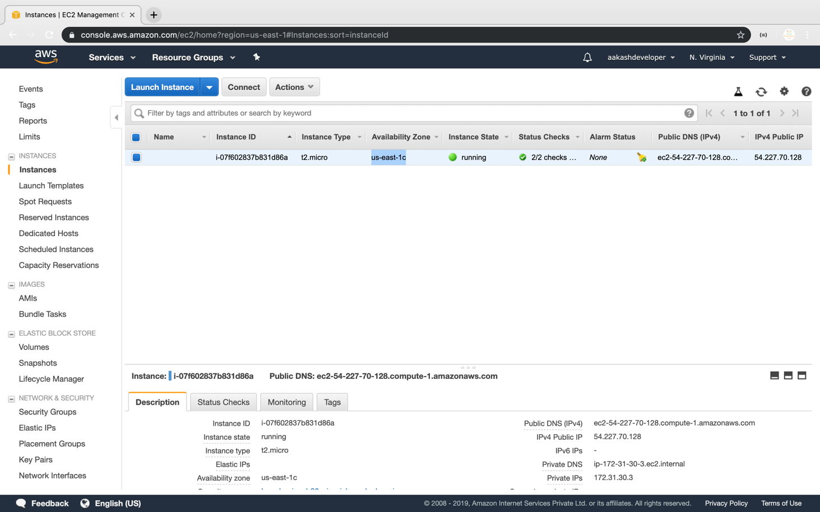

**Step 3:** Providing type, size, availability zone, and snapshot name on the **create volume** tab

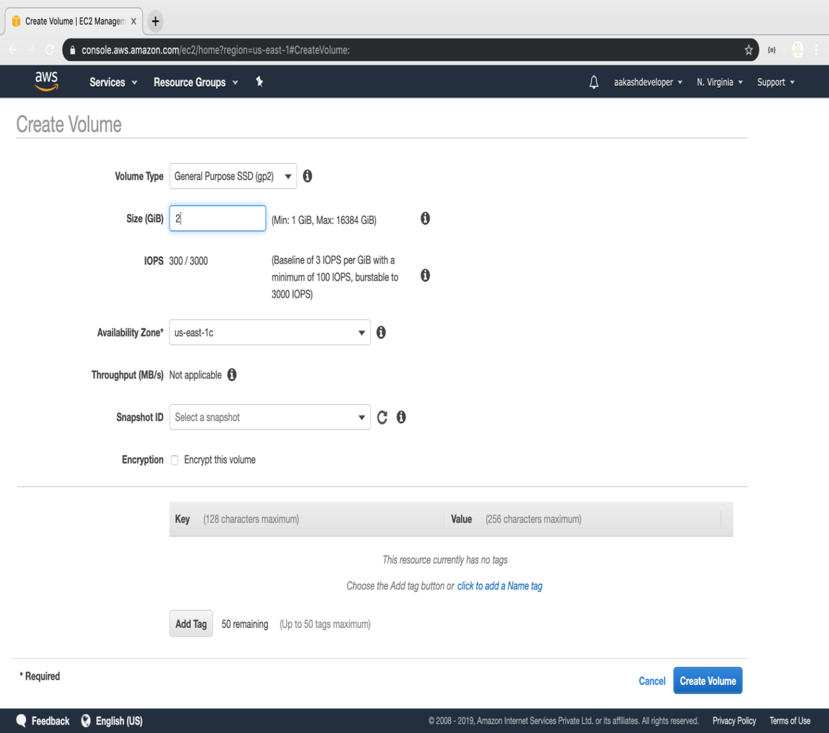

**Step 4:** Selecting newly created volume and clicking on the action to attach the volume to the instance

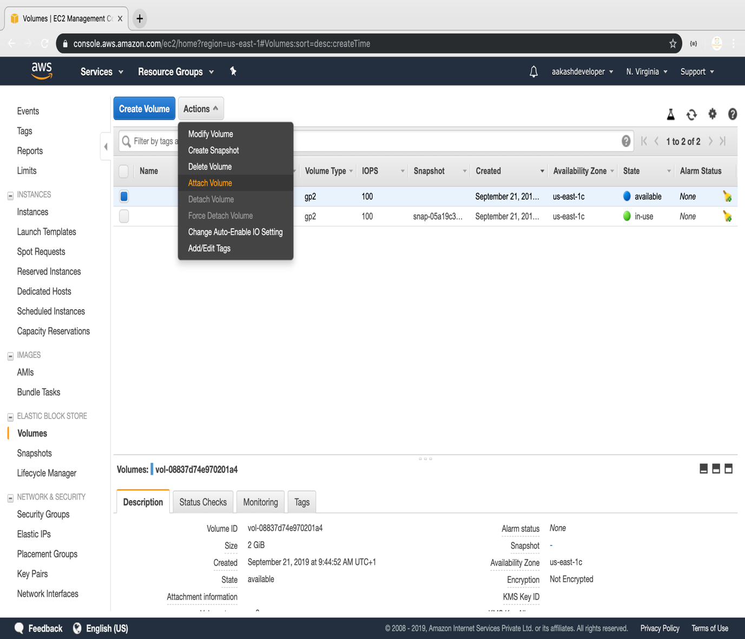

**Step 5:** Selecting the instance of the same availability zone and attaching the volume in pop

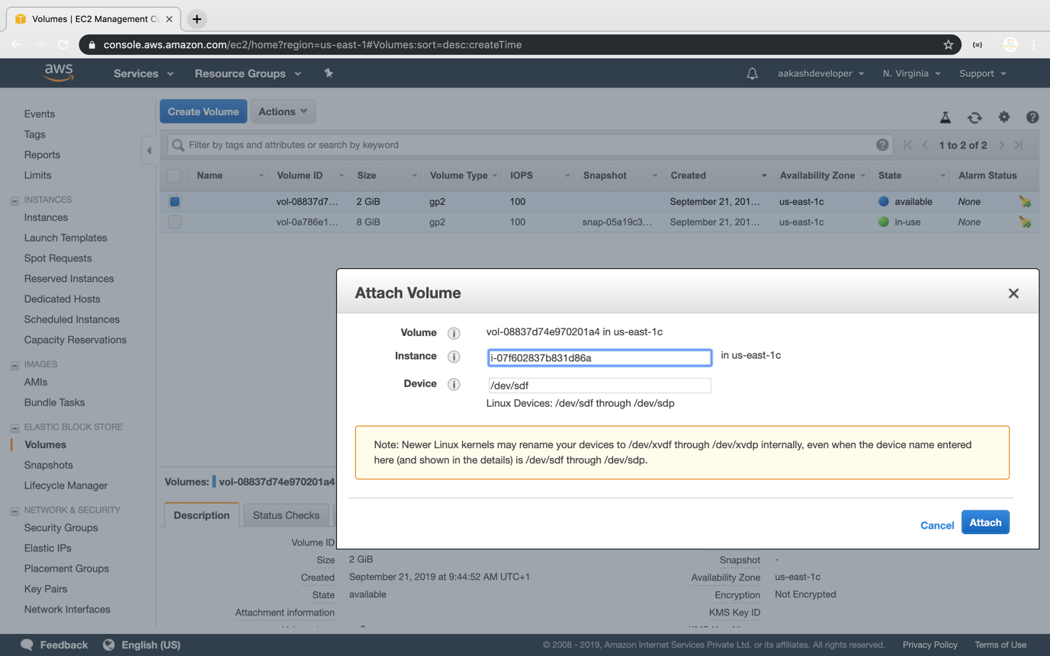

**Step 6:** Verifying the instance by adding one more device to the block device

